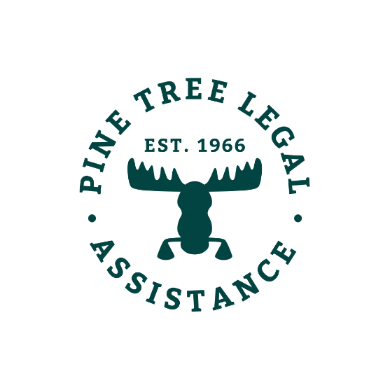

Tax Season Tips

Lots of money flows at tax time. And everyone wants a piece of it. Be smart and keep all of your refund. Here are our simple tips for holding onto your hard-earned money and tax credits.

Tip #1 – Say NO to Tax Scammers
- Many tax scams target low-income people and immigrants every year.
- If you get mail or a phone call from the IRS asking for your personal information, don’t give it to them! That message is a scam.

Tip #2 – Say NO to Hidden Fees
- Many for-profit tax preparers have high fees that they don’t tell you about up front.
- Before you let someone do your taxes, ask what those fees are for and how much they’ll be. Refuse to go any further if they’re too high.
- Keep all your hard-earned money and tax credits for yourself and your family. You deserve it! We recommend that you say no to all forms of tax prep fees.
Tip #3 – Say YES to Free Online Filing
- The IRS partners with companies who provide free online filing for people who made under $66,000 in 2017.
- Go to the IRS website to find out more about your free online filing options!
- Attention non-residents: the University of Texas at Austin’s online guide can help you prepare and print your taxes through an online program.

Tip #4 – Say YES to Tax Credits and Exemptions
- Check to make sure you took advantage of every tax credit and exemption you’re eligible for. These are especially valuable to low-income taxpayers:
- Earned Income Credit (EIC)
- Child Tax Credit
- Child and Dependent Care Tax Credit
- Educational Tax Credits
- If you didn’t have health insurance this year because you couldn’t afford it, you may be exempt from paying the penalty. Find out more about the “economic hardship” exemption on the IRS website.

Tip #5 – Say YES to Free Tax Help
- Qualified volunteers offer free tax filing help to low-income Mainers.
- Pine Tree Legal recommends using one of these free services. There are no fees and every return is checked by professionals. They make fewer mistakes than companies who charge you!
- Call 2-1-1 or go to cashmaine.org to find the service closest to you!

Learn your rights and find resources!
-Visit www.PTLA.org for more easy to read information about your legal rights
- If you have an issue with a previous year’s return contact PTLA – you may qualify for free legal help
-You can do this!

